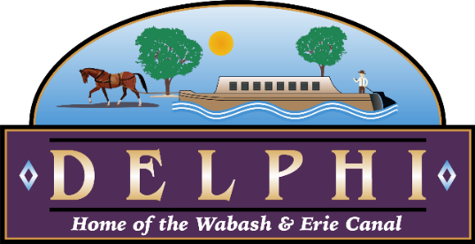
For Immediate Release:

CITY OF DELPHI ANNOUNCES ROUND TWO FOR SMALL BUSINESS RESILIENCE GRANTS

December 10, 2020 – The City of Delphi Common Council passed Resolution 2020-20 at its December 7th meeting authorizing a second round for the Delphi Small Business Resilience Grant (SBRG) program. Earlier this year the City made 36 SBRG awards totaling more than $161,000 to area businesses. Those grants were funded in part through a CARES Act grant received by the City of Delphi from the Office of Community and Rural Affairs that provided up to $198,600 to create and retain jobs meeting low to moderate income eligibility guidelines. With more than $110,000 remaining from the OCRA grant, the City is hoping to provide additional relief to Delphi businesses impacted by the COVID-19 pandemic.
The Small Business Resilience Grant is available to most businesses which have been located within the corporate limits of the City of Delphi since July 1, 2020 and which have fewer than 25 full-time-equivalent employees. The maximum possible award is $5,000 per business.
Applications are due by 4:30 p.m. on Friday, January 8, 2021. Further eligibility guidelines and information on how the funds may be used are available within the grant application.

The application and other necessary forms can be found at this link: https://cityofdelphi.org/business/delphi-sbrg

Inquiries about Small Business Resilience Grant program may be sent to Mayor Anita Werling at mayor@cityofdelphi.org.

###

